LAB ACTIVITY

Q1.

**Create a new workbook as shown below and save the file with your “**Name and Roll Number**”.**

1. Enter the labels and values in the exact cells locations as desired.
2. Use AutoFill to put the Employee Numbers into cells A5:A8.
3. Set the columns width and rows height appropriately.
4. Set labels alignment appropriately.
5. Use warp text and merge cells as desired.
6. Apply borders, gridlines and shading to the table as desired.
7. Format cell B2 to Short Date format.
8. Format cells E4:G8 to include Rs sign with two decimal places.
9. Calculate the Gross Pay for employee; enter a formula in cell E4 to multiply Hourly Rate by Hours Worked. 11. Calculate the Social Security Tax (S.S Tax), which is 6% of the Gross Pay; enter formula in cell F4 to multiply Gross Pay by 6%.
10. Calculate the Net Pay; enter a formula in cell G4 to subtract Social Security Tax from Gross Pay.
11. Save your work.

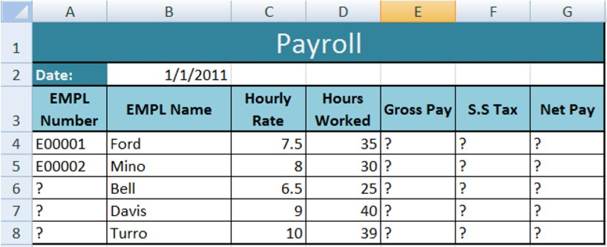

Q2.

**Create a new workbook as shown below and save the file with your “**Name and Roll Number”**.**

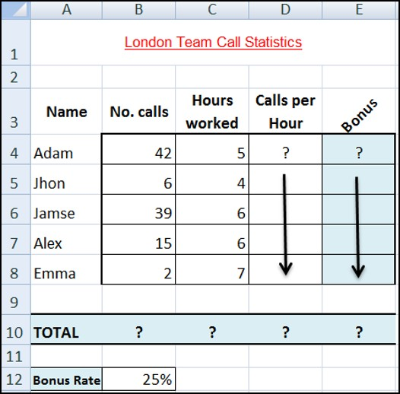

1. Enter the labels and values in the exact cells locations as desired.
2. Set the row height of rows 1 & 3 to size 30; and rows 4 until 10 to size 20.
3. Set labels alignment appropriately.
4. Use Warp Text, Orientation and merge cells as desired.
5. Apply border, gridlines and shading to the table as desired.
6. Format column E to include PKR sign with two decimal places.
7. Format cell B12 to include % sign with 0 Decimal places.
8. Calculate the Calls per Hour; enter a formula in cell D4 to divide numbers of calls by Hours worked. Using AutoFill, copy the formula to the remaining cells.
9. Calculate the Bonus. Enter a formula in cell E4 to multiply ‘Calls per Hours’ by the fixed Bonus Rate in cell B12. Using AutoFill, copy the formula to the remaining cells.
10. Calculate the ‘TOTAL’. 13. Set the worksheet vertically and horizontally on the page.
11. Create a header that includes your name in the left section, and your ID number in the right section. Create the footer that includes the current Date in the center.